
St Nicholas

Responsible User Agreement
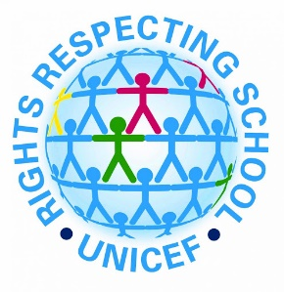
Guidelines for Usage of School & BYOD Devices

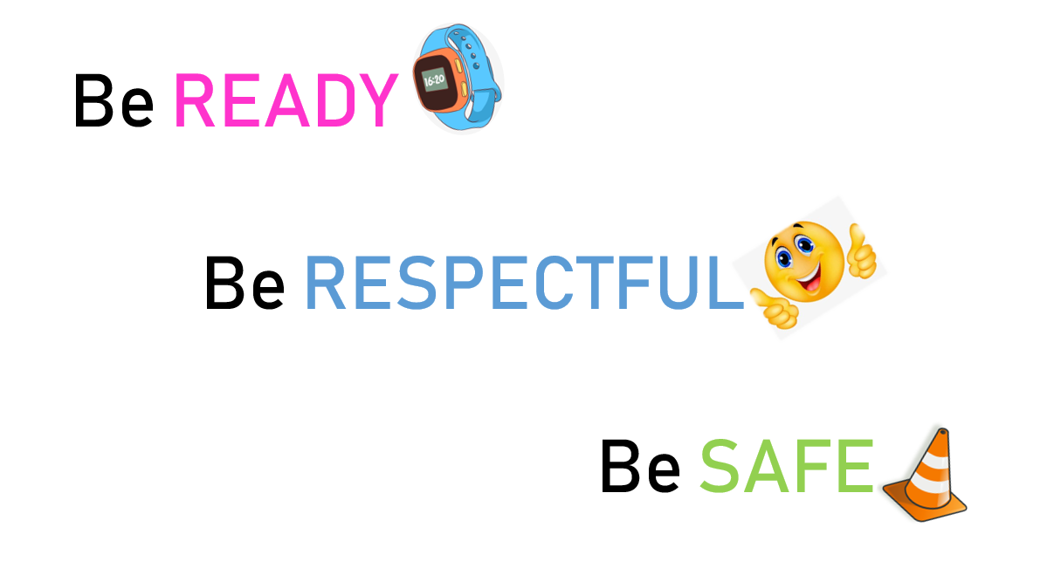
Our children have the right to the best education they can get, and the right to be safe. The internet and devices can be used to support and enhance our learning, but only if used sensibly and responsibly. Whilst learning, it is important that we stay safe, have fun, and make sure we don’t upset other people. We need to learn about how to use websites and social media safely. We need to take care of all devices and make sure the right people are using the right devices at the right time. Our 3 simple school rules can help us use technology in effectively and sensibly.

Green text Black Text

BYOD Pupils only
ALL pupils

Be READY
- I will make sure my device has a password / code before I bring it in.
- I will make sure my device and school devices are locked when not in use.
- I will make sure I know my all my login details and passwords.
- I will keep my device in the classroom during the school day, including break and lunchtimes, unless given specific permission by the teacher (for example outdoor learning).
- I will always look after all devices I am using.

- I am responsible for my device at all times, including during the journey to and from school.

- I will make sure my device is charged before school.

- I will use devices responsibly and sensibly, under the direction of the teacher. If I am not sure if it is a suitable time to use a device, I will ask my teacher.

Be RESPECTFUL

- I will always ensure all posts / comments / messages etc are kind, helpful or informative, and I’ll never post anything which is inappropriate or likely to cause harm or offence to others.

- I will make sure that I re-read any posts / messages before I send them, to ensure the content will not offend or upset anyone.
- I will be respectful of other student’s use of resources at all times.
- I will use the internet responsibly and only search for appropriate information. If I am unsure whether information is appropriate, I will speak to an adult before I start my search. If I find something inappropriate, I will tell an adult straight away.

St Nicholas

Responsible User Agreement
Guidelines for Usage of School & BYOD Devices

- I will make sure that my personal device is only ever used by me, and I know I am not to use anyone else’s personal device at any time.
- I will make sure that I am only using devices for educational / work related tasks and activities, and that I know that playing games is not permitted unless it is used for educational purposes or I am given permission by the teacher.
- I will only take photographs and videos of my own work. If I am creating videos or photos with others in, this will always be done ONLY with permission, and only on school devices. If I am uploading photos or videos to GLOW, I will ensure the connection is secure, I have permission from anyone in them, and I will only upload to GLOW, never any other website or social media.
- I will NEVER create / share / post anything which I would not wish other learners, teachers or parents to see.

- I am aware that EVERYTHING I do can be traced back to me at all times.

Be SAFE
- I will never share personal information over the internet (including name, address, age, phone numbers, etc).

- I will only share / comment / post on my secure GLOW account (this includes GLOW email, Teams, Sway, Glow OneDrive, Glow Powerpoint, Glow word, Glow Forms).

- I will always speak to an adult immediately if I see anything online which concerns me.

- I will always ensure my device is connected to the school’s secure AAL network, and the connection is secure (with the padlock). I will ensure my mobile data is turned off before use during the school day.
- I will make sure my device has a protective cover and my name on, every day.
- I will keep all personal information safe, even when using GLOW. If someone asks me for personal information I will tell my teacher straight away.
- I know I am not to use social media at all, at any time and I will only use age-appropriate websites and apps in school, at all times.
- I will be mindful that once something is online, that information may be beyond my control.

- I understand that any attempt to circumvent the schools network security and/or filtering policies is forbidden. This includes downloading programs to bypass security or accessing and setting up proxies.

All pupils are expected to be responsible and safe at all times when using technology, and must sign the user agreement regardless of whether or not they intend to bring in their own device. The user agreement covers use of school devices also. Unacceptable behaviour remains unacceptable whether it occurs in an online environment, the school playground, the toilets, the classroom or anywhere else.

St Nicholas

Responsible User Agreement
Guidelines for Usage of School & BYOD Devices

Pupil User Agreement (All Pupils)

- I agree to all of the above statements (in black).
- I understand if I do not behave in a suitable and appropriate manner, I may not be allowed to use devices in school.

Pupil’s Name

………………………………………………………………

Pupil’s Class

………………………………………………………………

Pupils Signature

………………………………………………………………

Date

………………………………………………………………

Pupil User Agreement (BYOD Pupils)

- I agree to all of the above statements including the additional green BYOD statements.
- I understand if I do not behave in a suitable and appropriate manner, I may not be allowed to bring my device into school.

Pupil’s Name

………………………………………………………………

Pupil’s Class

………………………………………………………………

Pupils Signature

………………………………………………………………

Date

………………………………………………………………

Parent / Guardian Permission

- I give permission for my child to bring a device into school, to enhance their learning.
- I understand my child will use a device in school, to enhance their learning.
- I have read and understand these rules about internet use, and I understand that my child will be expected to abide by these rules.
- I understand that West Lothian Council has provided as much protection as possible to ensure children are not exposed to sensitive material.
- I understand that any personal devices brought to school are done so at the responsibility of my child, and that my child is solely responsible for its care.
- I understand that the school does not have any additional insurance to cover any accidents with personal devices.

Parent / Guardian Name

………………………………………………………………

Parent / Guardian Signature

………………………………………………………………

